House Price Trend Analysis by using real estate data
Authors: B.Hema Lakshmi¹, A.S Siri Chandana², G.Satya Sindhur³, CH. B S Venkat⁴

Abstract: The primary objective of this project is to develop an intelligent and data-driven system for analyzing and predicting house price trends using real estate. Accurate property price estimation is essential for buyers, sellers, and investors in rapid growing urban markets . Since housing prices are influenced by multiple of bedrooms, amenities, and overall market conditions, traditional manual estimation methods are often inaccurate and inconsistent. Therefore, an advanced machine methods are often inaccurate and inconsistent. Therefore, and advanced machine learning based approach is required to improve reliability.
This project utilizes the publicly available house prices: Advanced Regression Techniques data-set from Kaggle, which contains structured real estate attributes and sale prices. The data-set undergoes systematic preprocessing, including handling missing values, feature encoding, and normalization. Exploratory Data Analysis (EDA) is performed to identify key patterns and influential variables affecting property prices.For predictive modeling, the XGBoost regression algorithm is implemented due to its high efficiency, regularization capability, and ability to handle complex nonlinear relationships. To validate model performance, comparative analysis is conducted using baseline models such as Linear Regression and Random Forest. The models are evaluated using standard regression metrics including Mean Absolute Error (MAE), Mean Squared Error (MSE), and R-Squared (R²) score. In addition to prediction, the incorporates trend visualization techniques to analyze price variation over time, enabling better understanding of market dynamics. The proposed approach provides an accurate, scaleable and practical solution for real estate price forecasting, supporting informed decision-making and reducing uncertainty in property investment.
Key Words : Data Science, Price analysis, Real Estate, Trends
I

Abstract—
Predicting residential property prices is a complex problem because house values are influenced by many interconnected factors such as location, physical characteristics, and market conditions. In fast-growing urban areas, accurate price estimation is important for buyers, sellers, and investors to make informed financial decisions. However, traditional valuation methods often rely on manual analysis, which may lead to inconsistent and less scalable results.
This study develops a machine learning-based approach for analyzing and predicting house price trends using the “House Prices: Advanced Regression Techniques” dataset from Kaggle. The dataset contains detailed residential property features along with corresponding sale prices. Data preprocessing steps, including handling missing values, encoding categorical variables, and normalization, are performed to prepare the data for modeling. Exploratory Data Analysis is conducted to understand key patterns and identify influential features.
Among different regression models, XGBoost is selected due to its strong performance in handling structured data and nonlinear relationships. The model’s effectiveness is evaluated using MAE, MSE, and R² metrics and compared with Linear Regression and Random Forest. The results show that the proposed model achieves improved prediction accuracy and provides meaningful insights into housing price trends.

Intro
The real estate market is a major sector that significantly influences economic growth and individual financial decisions. House prices depend on several interconnected factors, including location, property size, construction quality, number of rooms, neighborhood characteristics, and broader economic conditions such as interest rates and employment levels. These variables interact in complex ways, causing continuous changes in housing prices over time. Therefore, analyzing housing price trends and accurately predicting property values has become an important research area for buyers, sellers, investors, and policymakers [1].
Traditional approaches to house price estimation, such as linear regression and rule-based appraisal methods, often struggle to capture nonlinear relationships and feature dependencies present in real estate data. With the availability of large-scale housing datasets, these conventional methods have demonstrated limited predictive performance and generalization capability across different markets [2]. As a result, researchers have increasingly adopted machine learning techniques for real estate price prediction and trend analysis.
Machine learning models are capable of learning complex patterns from historical data and are widely applied in regression tasks [3]. Among them, ensemble learning methods have gained attention due to their ability to improve accuracy by combining multiple models. XGBoost (Extreme Gradient Boosting) is particularly effective for structured datasets and nonlinear feature interactions [4]. By sequentially constructing decision trees and minimizing residual errors, XGBoost achieves high predictive performance while controlling overfitting through regularization [5].
In this study, the XGBoost algorithm is applied to the Ames Housing dataset to analyze price trends and predict residential property values. The dataset provides detailed housing attributes, enabling systematic preprocessing, feature engineering, and performance evaluation using standard regression metrics.

Lireture survey:
A. Traditional and Hedonic Models
Hedonic pricing models estimate property values based on structural and locational features [6]. Harrison and Rubinfeld [6] showed these models work well for moderate datasets but lose accuracy with high-dimensional urban data, highlighting the need for more flexible approaches.
B. Handling Sparse and Complex Data with Random Forests
Urban housing datasets often contain many features, some of which are irrelevant or sparse. Random Forests address this by averaging multiple decision trees, reducing the effect of irrelevant features and minimizing overfitting [3]. This ensemble approach is particularly useful for markets like Bangalore, where property attributes vary widely and outliers like luxury villas can distort predictions. By combining feature selection implicitly with robust modeling, Random Forests efficiently handle sparse and complex real estate data.
C. Gradient Boosting and XGBoost
Gradient Boosting Machines (GBM) sequentially reduce prediction errors [5]. XGBoost, an optimized GBM, adds regularization, efficient computation, and missing value handling [4]. On structured datasets like Ames [7], XGBoost captures non-linear relationships among location, size, and price, providing accurate and stable predictions without overfitting.
D. Deep Learning Approaches
Deep learning models such as MLPs can achieve high accuracy on very large datasets but often overfit small- to medium-sized datasets [5]. Tree-based models like Random Forests and XGBoost remain preferable for urban housing markets with 10k–20k records due to interpretability and consistent performance.
Research Gap
Most studies focus on traditional econometrics or general machine learning comparisons. Few implement a full pipeline using Random Forests or XGBoost for structured datasets like Ames. This study fills the gap with an XGBoost-based framework optimized for complex real estate data.

III. SYSTEM ARCHITECTURE
The House Price Trend Analysis system is organized into a layered architecture to ensure accuracy, scalability, and interpretability in predicting property prices. The design is divided into four primary layers: Data, Preprocessing, Modeling, and Presentation.
Data Layer:
This layer relies on the Ames Housing dataset from Kaggle [7], which provides structured information about property features such as location, area, number of rooms, and amenities. It forms the foundation for the predictive analysis.
Preprocessing Layer:
Before modeling, the data undergoes cleaning, transformation, and feature engineering. Missing values are handled, categorical variables are encoded, and important features are selected to reduce noise. This ensures that the model receives high-quality input and improves prediction reliability.
Modeling Layer (XGBoost):
The core of the system is the XGBoost regression model, which captures complex, non-linear relationships among property attributes. With built-in regularization and efficient computation, XGBoost delivers stable and accurate price predictions even in datasets with varied and sparse features.
Presentation Layer:
Predictions are presented in a user-friendly format, such as dashboards, charts, or tables, allowing users to explore trends, compare actual versus predicted prices, and gain actionable insights.
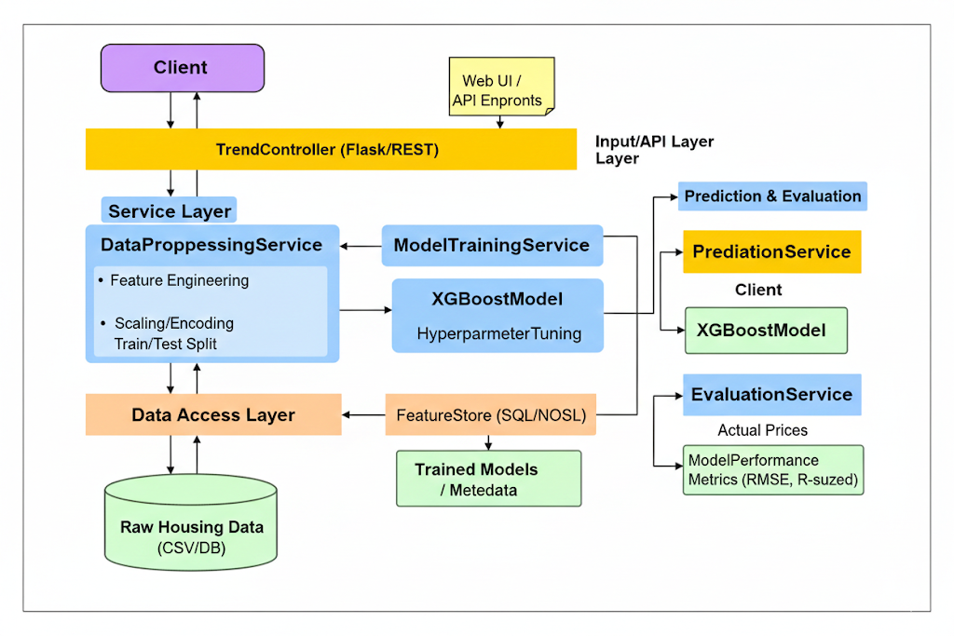
II. SYSTEM ARCHITECTURE
The House Price Trend Analysis system adopts a layered architecture to ensure logical data flow, scalability, and interpretability. The system is organized into four layers:
1. Data Layer
The foundation of the system is the Ames Housing Dataset from Kaggle. This layer stores detailed property attributes, including location, total area, room counts, and specific amenities, which serve as inputs for the analysis.
2. Preprocessing Layer
Raw data is transformed to prepare it for modeling. This layer performs:

Data Cleaning: Handling missing values and removing outliers.

Feature Engineering: Encoding categorical variables and scaling numerical features.

Feature Selection: Identifying the most relevant attributes to reduce noise and improve model efficiency.

3. Modeling Layer (XGBoost)
The core predictive engine is the XGBoost regression model. This algorithm captures complex, non-linear relationships in the housing market. Its built-in regularization reduces overfitting, supporting stable and reliable price predictions.
4. Presentation Layer
The system presents outputs through a user interface, including dashboards, trend charts, and comparison tables, allowing users to visualize predicted prices alongside actual market values.

